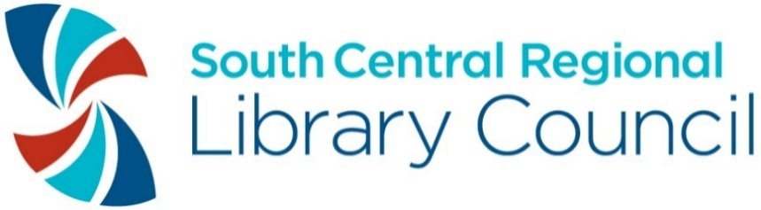

South Central Regional Library Council 2021 Awards
Call for Nominations

Nomination Deadline is Friday, October 8, 2021 @ 4:00 PM

Dear SCRLC Members,
I hope this message finds you well in our continuing extraordinary times. Through it all, you--the directors and staff of SCRLC members—have continued to serve and support the nearly one million residents living, working, and learning in our 14-county, 10,044 square mile region, through your programs and services, whether the buildings were open, or not.
Especially in such uncertain times, nominating a colleague for an award is one way to express your appreciation for their accomplishments, and to brighten their day!
The nomination process is easy. Think of whom you’d like to nominate and complete the attached form!
Awards will be presented at SCRLC’s Annual Meeting, which will be held virtually on Friday, October 22nd. The deadline for receipt of the nomination form is Friday, October 8, 2021, 4:00 PM.

Kindest regards,

Mary-Carol Lindbloom
Mary-Carol Lindbloom
Executive Director

SCRLC AWARD CATEGORIES

DIRECTOR OF THE YEAR
Presented to an outstanding director working on behalf of their library, museum, or organization.

LIBRARIAN OF THE YEAR
Presented to an outstanding librarian, working on behalf of their library or library system.

ASSISTANT OF THE YEAR
Presented to an outstanding assistant, library or otherwise, working on behalf of their library, museum, or organization.

SOCIAL MEDIA OUTREACH AWARD
Does your library or cultural organization reach its community through social media platforms? If yes, please send in a nomination for your favorite one—and link to favorite examples!

PUBLIC RELATIONS/EXHIBITION AWARD
Exhibitions—including virtual--are a great way to inform, educate, and promote resources and services. The Public Relations/Exhibition Award recognizes an outstanding campaign or exhibit that happened between July 1, 2020 and June 30, 2021.

SUSTAINABILITY AWARD
The Sustainability Award celebrates a member’s commitment to sustainability through activities that are equitable and inclusive, environmentally sound, and economically feasible. Examples include creating an inclusive collection development policy, installing solar panels or a bike rack, offering programs related to sustainability, organizing or participating in a relief effort, forging a new community partnership, going paperless, or creating a health and wellness program for library staff.

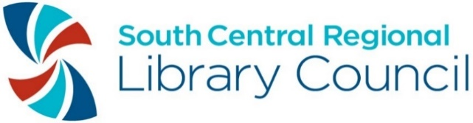
2021 SCRLC Award Nomination Form
This nomination is for the following award:

______ Director of the Year
______ Librarian of the Year Award
______ Assistant of the Year Award
______ Best Video Award (The Tubie)
______ Public Relations/Exhibition Award
______ Sustainability Award

Name and official title of person or library nominated for the award:

Home library/museum/organization of nominee:

Name of person making nomination:

Phone number of person making nomination:

E-mail address of person making nomination:

Library/museum/organization of person making nomination:

Describe in one page or less why this person/program should receive the award. Provide specific examples or statistics about how the library customers and community benefited from this person or program.

Please submit one copy of this form and your one-page nomination letter to:

South Central Regional Library Council
Attn: Diane Capalongo
Clinton Hall
108 N. Cayuga St.
Ithaca, NY 14850
dcapalongo@scrlc.org

By Friday, October 8, 2021at 4:00 PM.

Questions? Contact Diane Capalongo at dcapalongo@scrlc.org.

