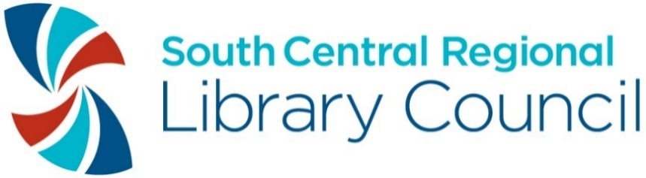

South Central Regional Library Council 2019 Awards
Call for Nominations

Nomination Deadline is Monday, September 23, 2019 @ 4:30 PM

Dear SCRLC Members,
The directors and staff of SCRLC members are on hand every day, serving the nearly one million residents living, working, and going to school in our 14-county, 10,000 square mile region.
Our members strive to provide astonishing and innovative programs and services for their clientele and to seek creative ways to stretch resources. They go out of their way to provide exceptional customer care.
Nominating a colleague for a SCRLC award is one way to express your appreciation for your co-worker’s accomplishments, and to brighten their day!
The nomination process is easy. Think of whom you’d like to nominate and complete the nomination form, which is attached. Descriptions of the awards are also included. You can also download a nomination form from our website at www.scrlc.org.
Awards will be presented at SCRLC’s Annual Meeting, which will be held on Friday, October 4th at Traditions in the Glen, Johnson City. The deadline for receipt of the application is Monday, September 23, 2019, 4:30 PM.

Kindest regards,

Mary-Carol Lindbloom

Mary-Carol Lindbloom
Executive Director
South Central Regional Library Council

SCRLC AWARD CATEGORIES

LIBRARIAN OF THE YEAR
Presented to an outstanding library director or librarian, working on behalf of your library or library system.

LIBRARY ASSISTANT OF THE YEAR
Presented to an outstanding library assistant working on behalf of your library or library system.

OUTSTANDING STUDENT WORKER OF THE YEAR
Many libraries would be hard-pressed to function without their student workers. This is a chance to honor an outstanding student employee.

BEST VIDEO AWARD (The Tubie)
Does your library or cultural organization reach its community through videos? If yes, please send the link to or a copy of the video that you would like to nominate!

PUBLIC RELATIONS/EXHIBITION AWARD
Exhibitions are a great way to inform, educate, and promote libraries’ resources and services. The Public Relations/Exhibition Award recognizes an outstanding exhibit from an SCRLC member who curated and/or hosted an exhibition from July 2018 through June 2019.

LIBRARY SUSTAINABILITY AWARD
The Library Sustainability Award celebrates a member’s commitment to sustainability through activities that are equitable and inclusive, environmentally sound, and economically feasible. Examples include developing an inclusive collection development policy, installing solar panels or a bike rack, offering programs related to sustainability, participating in a disaster relief effort, forging a new community partnership, making efforts to go paperless, or creating a health and wellness program for library staff.

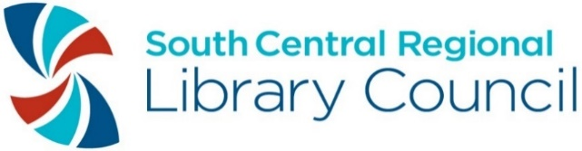
2019 SCRLC Award Nomination Form
This nomination is for the following award:

______ Librarian of the Year Award
______ Library Assistant of the Year Award
______ Outstanding Student Worker of the Year Award
______ Best Video Award (The Tubie)
______ Public Relations/Exhibition Award
______ Sustainability Award

Name and official title of person or library nominated for the award:

Home library of nominee:

Name of person making nomination:

Phone number of person making nomination:

E-mail address of person making nomination:

Library of person making nomination:

Describe in one page or less why this person/program should receive the award. Provide specific examples or statistics about how the library customers and community benefited from this person or program.

Please submit one copy of this form and your one-page nomination letter to:

South Central Regional Library Council
Attn: Diane Capalongo
Clinton Hall
108 N. Cayuga St.
Ithaca, NY 14850
dcapalongo@scrlc.org

By Monday, September 23, 2019 at 4:30 PM.

Questions? Contact Diane Capalongo at dcapalongo@scrlc.org.

