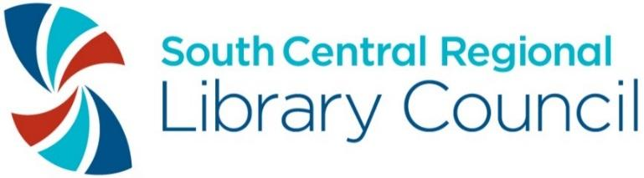

South Central Onsite Reciprocal Access Program (SCORA)
Borrower Application Form

NOTE: This form is kept on file by the Issuing Library to ensure the privacy of the individual.

Name ____________________________________________ Date __________

Undergraduate student____ Graduate Student ___ Faculty Member ___

Researcher/professional staff___

High school student – Advanced Placement, Concurrent Enrollment Program, International Baccalaureate

Home address ______________________________

Email address ________________________________________________________

Daytime Phone Number ___________ Evening Phone Number _________________

Library ID or other identifying number (specify) ______________________________

SCORA Card # ____________

Date Issued _______________

Expiration Date _______________ Renewed Date(s) ________________________

Comments:

SCORA CARD RULES AND REGULATIONS AND SIGNATURE (REQUIRED)

- Each SCORA Card is non-transferable and can only be used by the person to whom it was issued
- Use of the SCORA Card is subject to the rules of each participating library.
- Replacement costs for lost or damaged materials must be paid by the person whose signature appears on the card.
- Overdue fines are payable to the lending library by the person whose signature appears on the card.
- The card does not give automatic entrance to participating libraries. Borrowers must check hours and requirements for appointments of participating libraries.
- Lending libraries may restrict access to certain categories of SCORA Card holders.
- Cards are valid for a maximum of one year, from Jan 1 to Dec 31, with no automatic renewals. Exceptions include:
  - If the patron applies for the card within the last two month of the calendar year (November or December), the expiration date will be the following year.
  - If a student is graduating in the current year of the issued SCORA card, the expiration date will be prior to their graduation date.

- Photo IDs: The Issuing Library staff must ask for appropriate ID, which should include a picture ID. Some high schools in the SCRLC region do not issue picture IDs. Some students in those schools will have driver’s licenses. A student lacking a photo ID is encouraged to obtain a non-driver ID. The school library may also be able to facilitate access to the lending library on behalf of the student by calling ahead. SCRLC will investigate ways of funding non-student IDs on a case-by-case basis.

I have read and understand the rules and regulations governing the use of the SCORA Card.
I further acknowledge that failure to return borrowed material or pay fines owed the lending library will result in the permanent loss of my SCORA Card privileges.

Signature_______________________________________________________________
(Required)

Print name _____________________________________________________________

Date_____________________

Issuing Librarian’s Name____________________________________________

Issuing Librarian’s Email____________________________________________ Date_______

About the SCORA Card
WHAT? SCORA is SCRLC’s reciprocal access/direct borrowing program in which members can participate. It enables the registered users of participating members to create a library account and check out materials from other participating libraries, in person. SCORA does not replace existing reciprocal onsite agreements; it increases the opportunities for users to borrow onsite from a larger number of libraries.

WHO? It is available to current faculty, graduate students, undergraduates, professional and research staff of participating institutions, serious researchers through their public library, and selected high school students. The card is non-transferable.
WHERE? SCORA cards are issued by the user’s own library. SCRLC does not issue access cards to individuals. The SCORA card may be used at the participating libraries listed below, which also lists the participants’ levels of access and lending policies.

WHEN? SCORA cards are issued to eligible users when they need to use other participating libraries and only after their home library’s resources have been exhausted. SCORA cards are not designed for use when interlibrary loan would suffice.
WHY? SCRLC was chartered “to improve reference and research library services with the area, and to promote interlibrary cooperation in the use of such resources.” This is one of a variety of services developed by SCRLC to achieve this, i.e., helping library users to obtain the information resources at their point of need.

