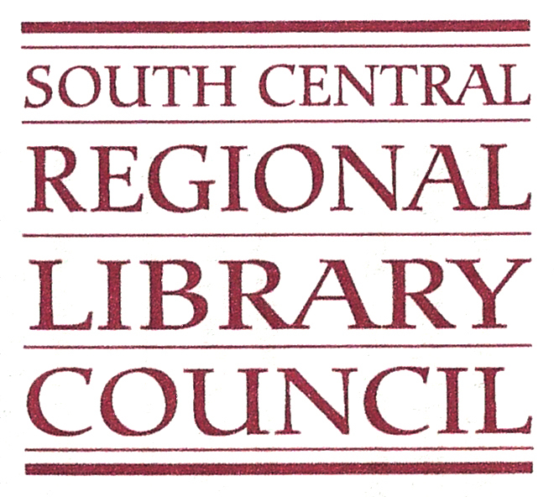

Report from the SCRLC Nominating Committee
The SCRLC Board of Trustees Nominating Committee presents the following nominations
for Board of Trustees for terms beginning in 2017:

James Galbraith, Chief Librarian, Corning Museum of Glass, for a first partial term, ending in 2019.
James Galbraith joined the Museum in 2013. He oversees all aspects of the Rakow Library, including the archives, digital and print collections, public services, digital initiatives, library acquisitions, exhibitions, and the Museum’s office of rights and reproductions. Galbraith’s background is in library management. He has held collection development positions in academic libraries since 1999, including the University of California–Irvine, Wake Forest University and Columbia University. His professional affiliations include the American Library Association and the Association of College and Research Libraries. Galbraith holds a master’s of library science degree from University at Buffalo, The State University of New York. He received a master’s degree in history from the University of Illinois at Urbana-Champaign and a bachelor’s degree from State University of New York at Buffalo. Galbraith came to the Museum from DePaul University in Chicago, IL, where he served as the associate director for collections and scholarly resources.
Sarah Glogowski, Executive Director, Finger Lakes Library System, for a first full term, 2017-2021.
Sarah Glogowski joined FLLS as the new Executive Director officially on July 6, 2015. Before that, she was the Head of Youth Services at Tompkins County Public Library. Sarah started her career at TCPL in 1999 as an Adult Services Librarian specializing in readers’ advisory, public programming, and community engagement. Over the years she implemented many new services, including email reference, book discussion groups and the start of the Cornell/Ithaca Community Read. She also worked on large scale community projects such as the MLK Build.
Sarah is a past president of the Ithaca Downtown Business Women group and a board member of Leadership Tompkins (past President). She also serves on the TST BOCES school librarian system advisory council as a public library system representative.
In addition to her work at TCPL, Sarah has worked at the New York State Library’s Newspaper Project, the New York State Department of Economic Development as a business library intern, and as a clerk at her hometown library, Weller Library. She received her Master’s in Library Science from SUNY Albany.

Gregg Kiehl, Library Director, Tompkins Cortland Community College, for a first partial term, ending in 2017.
Gregg R. J. Kiehl joined TC3 as the Director of the Library in 2008. He received his MLS and MA English degrees from SUNY Albany. Gregg began his career as the site librarian for IBM at their Poughkeepsie, New York branch and later accepted a position as Head of Circulation/ILL services at SUNY Cobleskill.
Gregg has a long, successful history of leading organizational change in libraries and is largely responsible for introducing many of the library’s innovative services such as purchase-on-demand, text book program, lecture capturing, and video streaming.
Susan LeBlanc, School Library System Director, Delaware-Chenango-Madison-Otsego BOCES, for a first full term, 2017-2021.
Prior to her current position, Ms. LeBlanc was the Library Media Specialist for grades 7-12 at Otselic Valley Central Schools in South Otselic, NY. She also served as a graduate assistant at the Center for Digital Literacy at Syracuse University, and a volunteer literacy coordinator, where she developed, implemented, and ran a literacy outreach program that connected registered therapy dogs with young readers. Ms. LeBlanc holds an MLIS with a School Media Specialization from Syracuse University, and a NY State School Building Leader Certification. Her BS is in Liberal Arts from Excelsior College in Albany.

Sarah Glogowski
Chair, Nominating Committee
October 2016

